**How to Download and Install Selenium ID**

1) Launch ***Mozilla Firefox*** Browser.  
2) Type URL: https://addons.mozilla.org/en-us/firefox/addon/selenium-ide/ in your browser. Selenium IDE Add-ons page will get open then Click on ***Add to Firefox*** button as shown in image bellow.

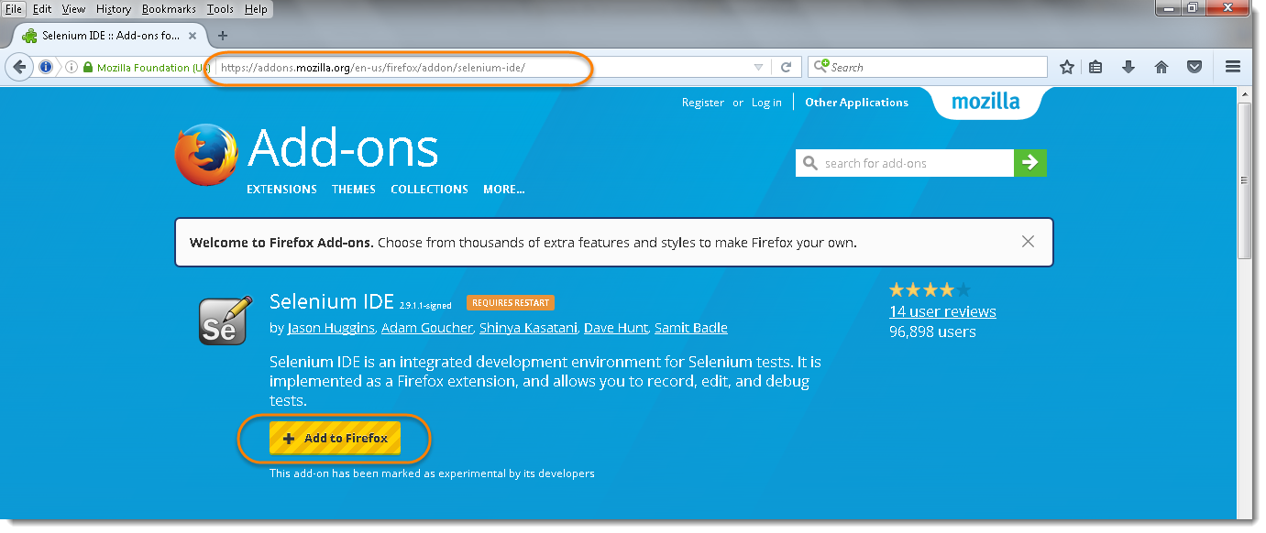

3) Firefox will show one popup saying do you want to allow Mozilla Firefox to install Selenium IDE Add-ons or not. ***Click*** on ***Install*** button as Shown in Image below.

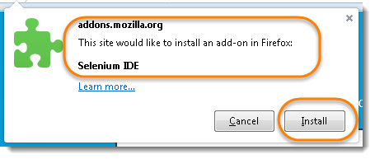

4) Firefox will automatically install Selenium IDE software. After the installation is completed, a pop up window appears asking to re-start the Firefox. Click on the “Restart Now” button to reflect the Selenium IDE installation. ***Click*** on ***Restart Now*** button.

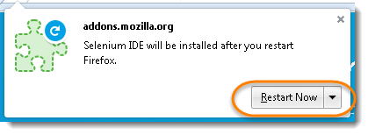

5) On clicking on the Restart Now button, Firefox will restart automatically. In case you missed the pop-up, simply close the Firefox and launch again. Once the Firefox is booted and started again, we can see selenium IDE under the tools menu list. ***Click*** on ***Tools*** menu list displayed at the top bar. ***Selenium IDE*** will be displayed in the list.

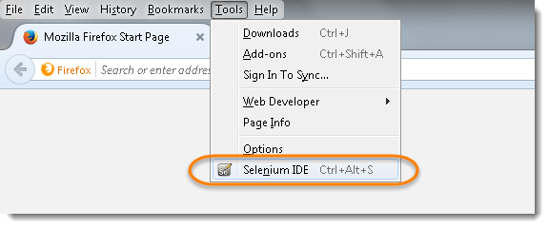

6) ***Click*** on ***Selenium IDE,*** it will launch Selenium IDE.

